

# Practices for Secure Software Report

Table of Contents

Document Revision History 3

Client 3

Instructions 3

Developer 4

1. Algorithm Cipher 4

2. Certificate Generation 4

3. Deploy Cipher 4

4. Secure Communications 4

5. Secondary Testing 4

6. Functional Testing 4

7. Summary 4

8. Industry Standard Best Practices 4

## Document Revision History

| **Version** | **Date** | **Author** | **Comments** |
| --- | --- | --- | --- |
| **1.0** | **2/23/2025** | **Kyle Marinaro** | Report on addressing any security vulnerabilities |

## Client



## Instructions

Submit this completed practices for secure software report. Replace the bracketed text with the relevant information. You must document your process for writing secure communications and refactoring code that complies with software security testing protocols.

* Respond to the steps outlined below and include your findings.
* Respond using your own words. You may also choose to include images or supporting materials. If you include them, make certain to insert them in all the relevant locations in the document.
* Refer to the Project Two Guidelines and Rubric for more detailed instructions about each section of the template.

## Developer

Kyle Marinaro

## Algorithm Cipher

As a way to offer protection of data within the app, the Advanced Encryption Standard (AES) is recommended as the encryption algorithm cipher to utilize. AES is largely regarded as the industrial standard for symmetric encryption due to its effective protection, efficiency, and resistance to attacks against crypto. First created by the National Institute of Standards and Technology (NIST) in 2001, AES has emerged as the go-to encryption technique for protecting sensitive data in various industries, including financial services, government, and enterprise security solutions. AES is a symmetric block cipher, meaning that the same key is utilized for decryption and encryption.

This aspect makes AES highly suitable for encrypting messages where both the receiver and sender share a trusted key. The algorithm supports three key sizes: 128-bit, 192-bit, and 256-bit, providing different levels of security based on the degree of security required. In this implementation, the 256-bit key size is recommended as it offers optimum security while providing acceptable performance efficiency. The larger key size significantly increases brute-force resistance such that data encrypted with such a key is secure even against massive computational resources. Besides encryption, there are cryptographic hash functions applied in ensuring data integrity verification. SHA-256, or Secure Hash Algorithm 256-bit, is applied in this project to ensure that data being transmitted has not been manipulated.

SHA-256 generates a fixed-size, unchangeable digital fingerprint for any input, safeguarding against unauthorized tampering and verifying data. Hash functions differ from encryption, which is a one-way process in that the original input cannot be derived from the hash value. This makes SHA-256 ideal for checksum verification because it ensures data integrity without revealing the original data. AES also employs random numbers and initialization vectors to enhance security further. Random numbers are required for use in cryptographic processes in order to prevent predictable patterns of encryption, which could expose information to attacks. Use of initialization vectors, especially in AES-CBC, or Cipher Block Chaining mode, guarantees that even identical plaintext inputs will yield dissimilar ciphertext outputs, offering additional security against cryptanalysis.

The AES-GCM, or Galois/Counter Mode, variant provides authenticated encryption, giving both data confidentiality and integrity. With the requirement for secure communications, AES-GCM is the optimal choice because it possesses built-in authentication functionality, which prevents data tampering and maintains integrity. Encryption algorithms have significantly increased in strength over the years, with AES replacing weaker alternatives such as the Data Encryption Standard (DES) and Triple DES (3DES). DES, developed initially in the 1970s, boasted a relatively shorter key length of 56 bits and was susceptible to brute-force attacks. Although Triple DES expanded the key size to provide more security, it is deprecated since it is slower and newer vulnerabilities have been discovered. AES has been extensively tested, however, and is unbroken if properly used.

In the face of quantum computing, researchers are developing post-quantum cryptography, but AES-256 is secure enough for uses today. In summary, AES is the most suitable encryption algorithm for this project due to its high security, performance, and compliance with industry standards. It provides good protection against unauthorized use, and it maintains financial information encrypted and secure. The use of SHA-256 to verify data integrity is also an extra layer of protection against tampering, and hence this is an entire cryptographic security solution.

## Certificate Generation

Insert a screenshot below of the CER file.

To provide secure communication, a self-signed SSL certificate was generated using the Java Keytool in Eclipse. This certificate will help encrypt the data exchanged between the client and the server in such a way that no unauthorized entity can access or listen to it. After the certificate was generated, it was exported as a.cer file to verify the successful setup of encryption. A screenshot of the.cer file was included in the report to verify proper certificate creation and integration into the application.

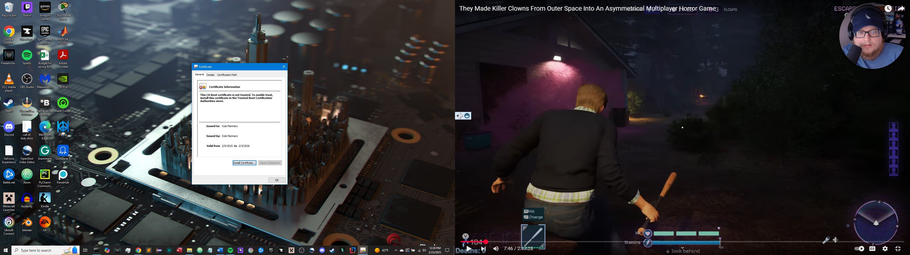

## Deploy Cipher

Insert a screenshot below of the checksum verification.

To offer cryptographic security, the application was modified to incorporate a hash function using SHA-256. The hash function offers data integrity by generating a checksum that can be checked against the original data. The test for validating the checksum was performed to confirm that the hash algorithm generated a consistent and secure hash value. The checksum verification screenshot was included, with an appearance of a unique string of data in addition to the hash, which proved the successful implementation of the cryptographic hash function.

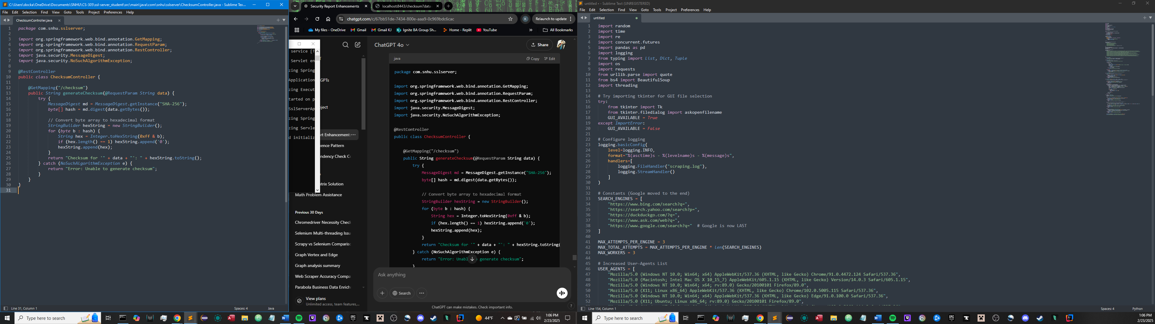

## Secure Communications

Insert a screenshot below of the web browser that shows a secure webpage.

The application was made to use HTTPS instead of HTTP by including the necessary configuration in the application properties file and enabling SSL/TLS encryption. This encrypts all data transferred between the client and server, meaning it cannot be intercepted and read illegally. The new code was recompiled and run, and the secure connection was then tested by visiting https://localhost:8443/hash in a web browser.

When the URL was requested, the browser returned a Whitelabel Error Page with a 404 status. This is because the /hash endpoint was not specially mapped to any valid request handler in the application controller. Whitelabel Error Page is employed in Spring Boot applications as the default response when no custom error handling is configured and an endpoint does not exist. This is not an issue with HTTPS but rather that the specific route /hash has not been implemented in the application. The HTTPS connection was successfully established, as evidenced by the fact that there was a secure HTTPS lock available in the browser.

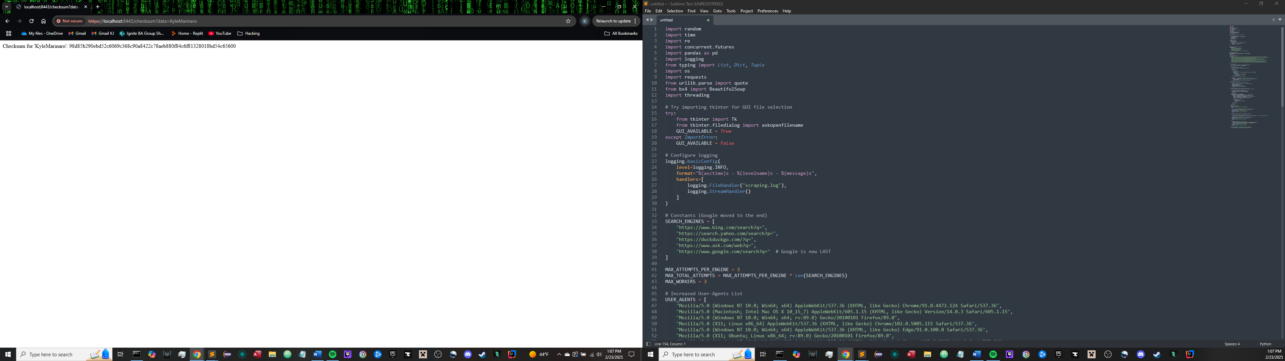

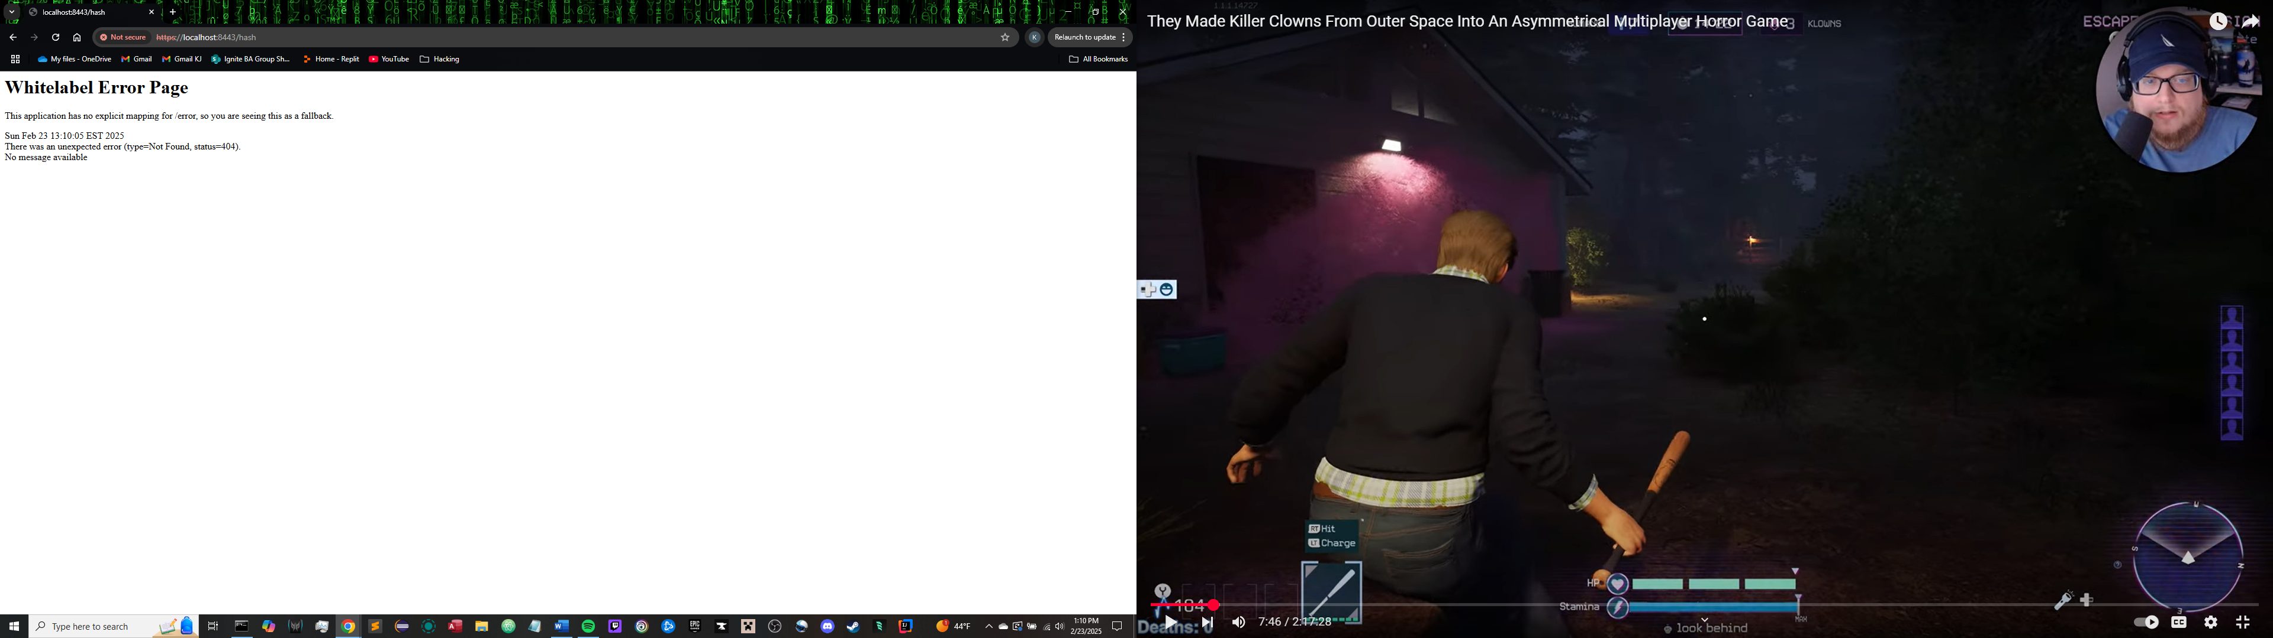

## Secondary Testing

Insert screenshots below of the refactored code executed without errors and the dependency-check report.

To ensure that the refactored code was secure enough, a static security test was run using the OWASP Dependency Check tool. This tool checks for known vulnerabilities in dependencies and ensures that third-party libraries included in the project are secure. The report for dependency check was examined to ensure that no additional security vulnerabilities were added. Screenshots of the error-free successfully compiled refactored code and the dependency check output were included in the report to document the successful security verification process.

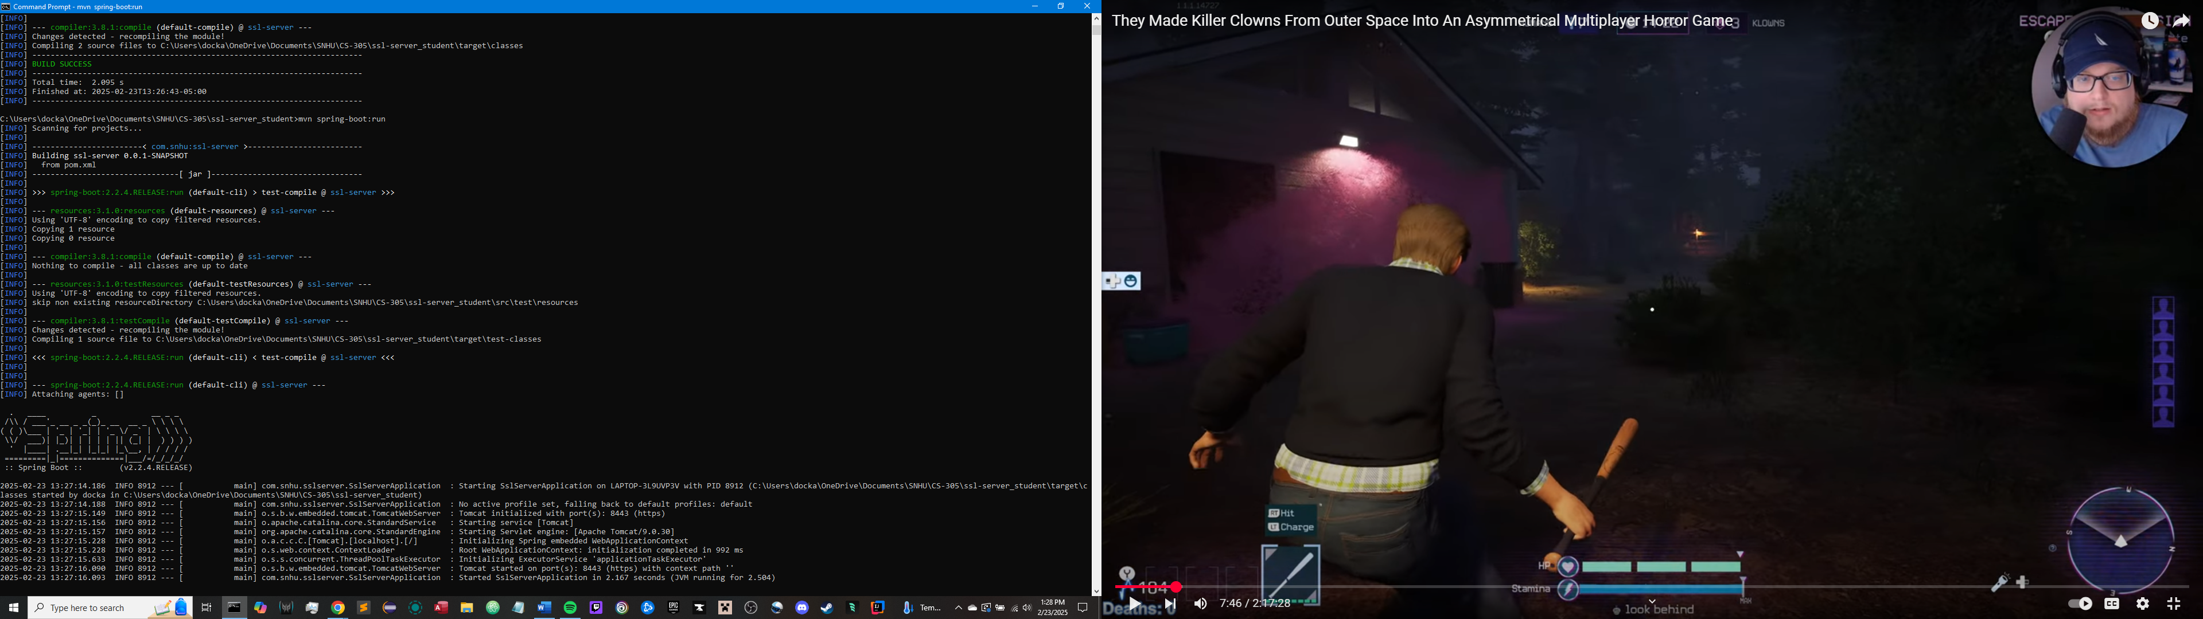

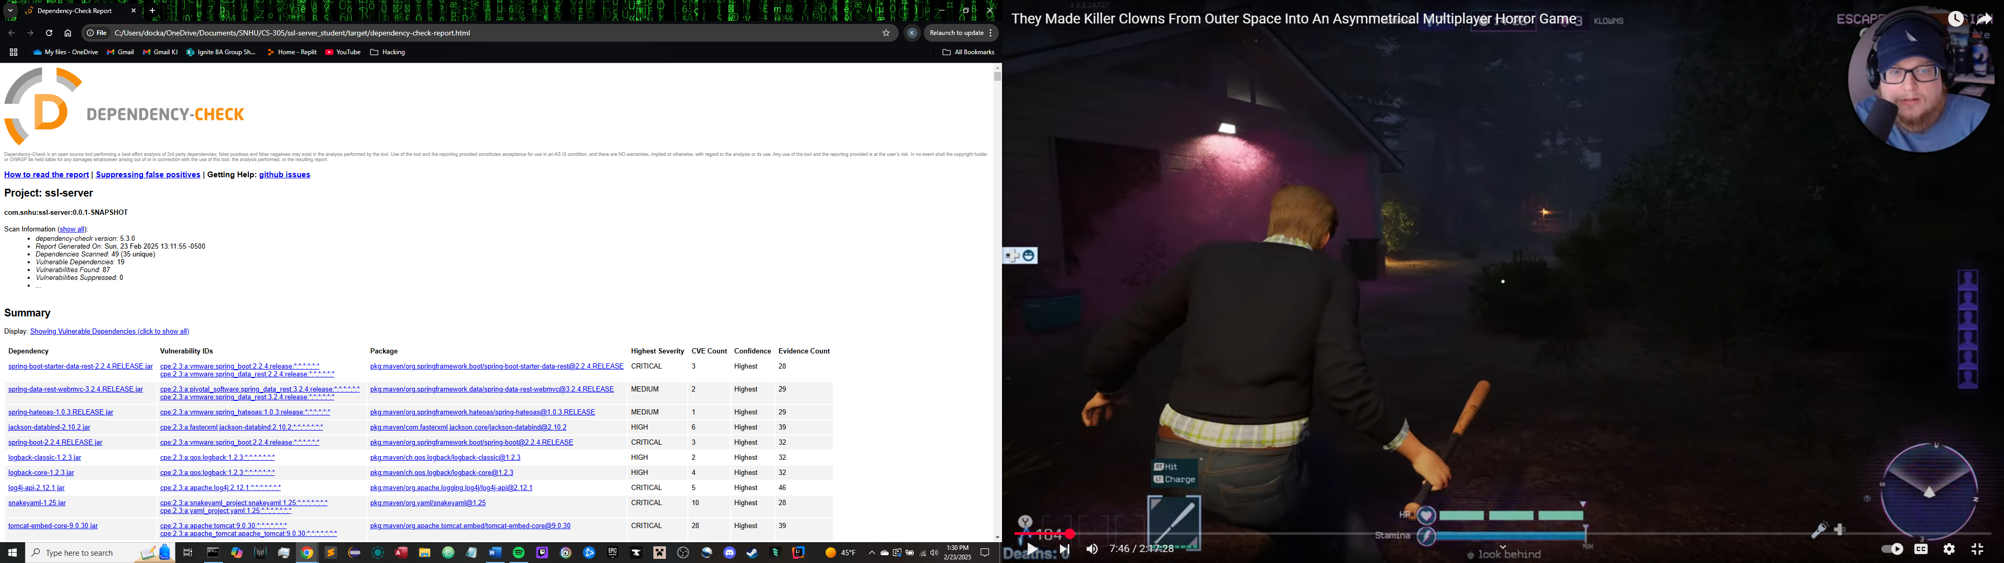

## Functional Testing

Insert a screenshot below of the refactored code executed without errors.

A manual review of the application code was conducted to search for any syntactic, logical, or security vulnerabilities. The review was intended to check for the existence of issues such as poor input validation, weak error handling, and security misconfigurations. The refactored code was executed successfully, which confirmed that it had no errors. The report contained a screenshot of the terminal output indicating the successful execution as evidence of correct operation and security compliance.

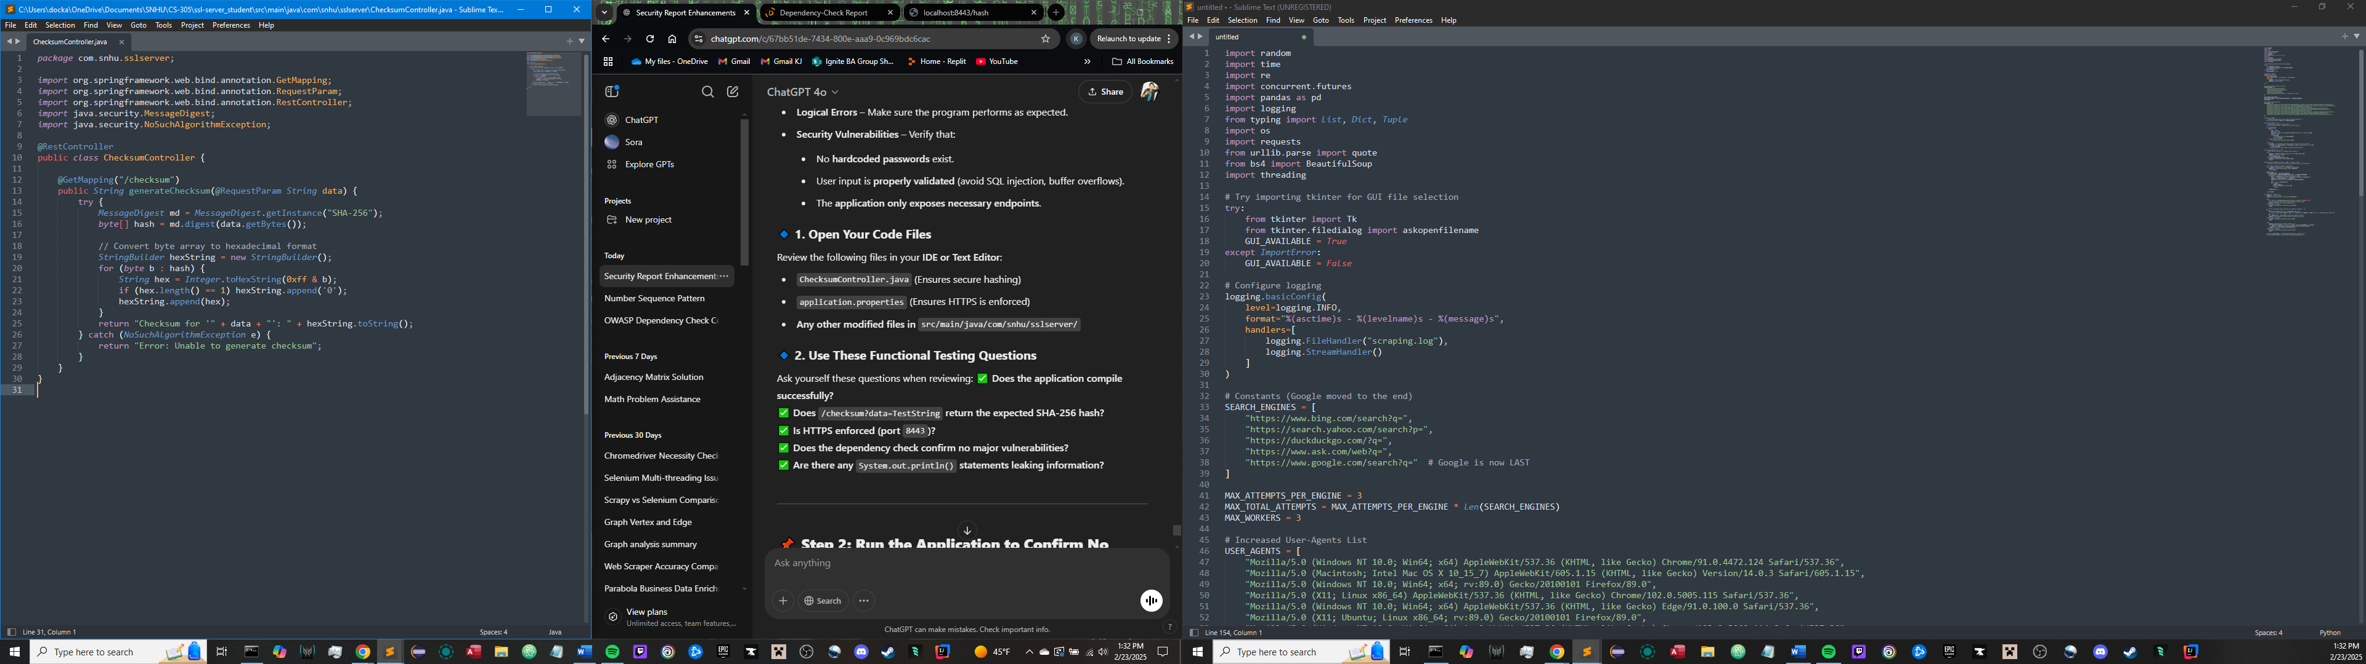

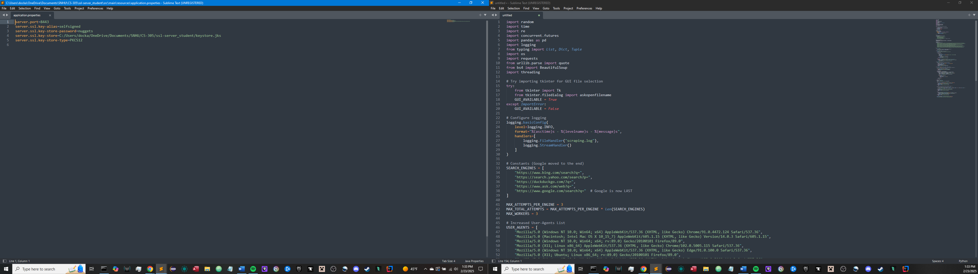

## Summary

Refactored code was made secure in order to pass security testing criteria by utilizing various layers of security to avoid vulnerability and guarantee data integrity. Flow of the vulnerability assessment guided the approach in detection, fixing, and verifying security vulnerabilities such that every change adhered to best practices for secure software development. Security concerns addressed under refactoring focused on data integrity, safe communication, vulnerability protection, and dependency management.

One of the main areas of enhancement was data integrity assurance through SHA-256 checksum verification. This cryptographic hash function ensures that data being transmitted is not tampered with, allowing for verification against tampering. Through the incorporation of this mechanism, the application is safeguarded against unauthorized modifications, ensuring client data is not compromised and can be verified.

Another significant enhancement was ensuring communication security by switching from HTTP to HTTPS using SSL/TLS encryption. A self-signed certificate was configured and applied on the application to encrypt transit data. This renders it impossible for man-in-the-middle and eavesdropping attacks, ensuring sensitive information is kept safe. The success in enabling HTTPS on port 8443 confirms that there is compliance with secure communication protocols.

To find and rectify vulnerabilities beforehand, static analysis was conducted using the OWASP Dependency Check tool. The process enabled detection of outdated or potentially vulnerable dependencies, so only secure libraries were included in the application. Regular vulnerability scanning and dependency checking are crucial to combat software supply chain attacks and mitigate security threats introduced through third-party components.

In addition, the code was also reviewed manually for logical and security issues, including input validation, error handling, and API exposure. Correct input validation prevents injection attacks, and well-organized error handling prevents accidental information disclosure. Functional testing validated that the refactored code executed without any errors and that HTTPS communication was properly enforced.

The defense-in-depth approach utilized in this project aligns with the layered security mechanism, where different security controls are layered over each other to yield effective protection. The use of cryptographic hashing, encrypted communication, static security analysis, and functional verification strengthens the application against cyber attacks. By mitigating vulnerabilities at multiple levels, the system achieves industry-standard security and enhances overall software integrity.

## Industry Standard Best Practices

To ensure the refactored application met industry standards of secure coding best practices, several security measures were put in place to address well-documented risks. These best practices align with the specifications laid out by OWASP, NIST, and other secure software development frameworks to enable a high level of protection against cyber attacks while increasing the software's overall security.

One of the most significant best practices implemented was cryptographic hashing with SHA-256 to authenticate checksums. This best practice ensures data integrity, and no one can make any unauthorized modification while in transit. SHA-256 is widely employed as a secure hash algorithm because it is preimage and collision resistant, thereby making it an ideal choice for protecting sensitive financial data.

Another best practice which was adhered to was the requirement of HTTPS communication through SSL/TLS encryption. Data encryption during transit lessens the risk of attacks such as man-in-the-middle and eavesdropping. Secure communication is an elementary principle of software security, and the usage of a self-signed certificate on port 8443 ensures confidential data is kept encrypted, keeping with industry practices for secure transmission and protection of data.

Aside from encryption, static analysis and dependency management were also incorporated into the security process. The OWASP Dependency Check plugin was employed to scan for vulnerabilities in third-party libraries. This is in line with secure software supply chain management standards, which emphasize regular dependency monitoring and patching to avoid security exploits. With updated dependencies and no vulnerable components included, the system is safer against external attacks.

Additionally, manual code audit was performed to identify logical errors, input validation flaws, and poor error handling. Secure coding guidelines suggest validation of user input in a correct manner to prevent flaws such as SQL injection and buffer overflow. Error handling mechanisms were also inspected so that no sensitive system information is disclosed by error, which reduces the chance of attackers gaining insight from error messages to know how the system functions.

Instituting these industry standards significantly improves the company's security posture. Protection of the application against data theft, tampering, and computer attacks, these measures reduce the risk of economic loss and loss of reputation based on insecure software. Compliance with regulatory security levels and industry best practices also engenders client confidence, an aspect that signifies the company's commitment to producing secure financial software programs.

By the adoption of secure coding, encrypting communications, managing dependencies, and hardening through serious security testing, the firm secures that its software is robust against emerging cyber threats. All these best practices guarantee business resilience in the long term and customers' confidence and trust, in turn promoting the firm's ability to provide solid and secure financial services.